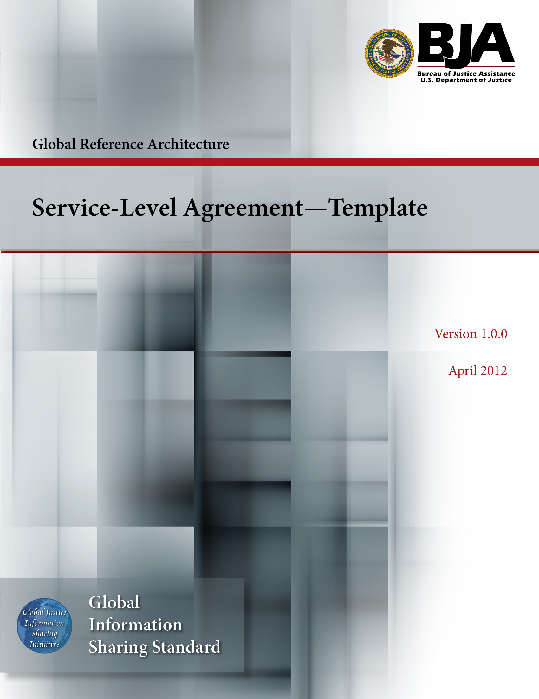


The Global Reference Architecture (GRA)

[Service Name] [Service Abbreviation] [Service Version]

Service-Level Agreement (Template)

Version 1.0.0

By [Name of Organization]

[Month Year]

Table of Contents

Document Conventions iii
1. Purpose 1
2. Description 1
2.1 Included in Service 1
2.2 Not Included in Service 1
3. Version 1
4. Applicable Policies, Status, and Rules 1
5. Problem Reporting 1
6. Problem Escalation 1
7. Change Control 1
7.1 Obligations of Provider 1
7.2 Obligations of Consumer 1
7.3 Additional Considerations 2
8. Service Context 2
9. Eligibility, Access, and Acceptable Use 2
10. Governance and Authority 2
11. Security 2
12. System of Record, Confidentiality, and Audit 2
12.1 Confidentiality 2
12.2 Audit 2
13. Data Quality 2
14. Nonconformance, Corrective Actions, and Consequences 2
14.1 Definition of Nonconformance 2
14.2 Corrective Actions 3
14.3 Consequences and Service Termination 3
15. Fees and Costs 3
16. Liability 3
17. Governing Law, Jurisdiction, and Disputes 3
18. Durability of Service 3
19. Order of Precedence Statement 3
20. Notices 3
21. Signature Section/Contract Authority 5
Appendix A—References 6
Appendix B—Glossary 7
Appendix C—Document History 8

Document Conventions

[Note: The following template is provided for use with the Service Development Process. Text enclosed in square brackets and/or displayed in blue is included to provide guidance to the author and should be deleted before publishing the document.]

Service-Level Agreement (Template)

Purpose

[Include section text here.]

Description

[Include section text here.]

Included in Service

[Include section text here.]

Not Included in Service

[Include section text here.]

Version

[Include section text here.]

Applicable Policies, Status, and Rules

[Include section text here.]

Problem Reporting

[Include section text here.]

Problem Escalation

[Include section text here.]

Change Control

[Include section text here.]

Obligations of Provider

[Include section text here.]

Obligations of Consumer

[Include section text here.]

Additional Considerations

[Include section text here.]

Service Context

[Include section text here.]

Eligibility, Access, and Acceptable Use

[Include section text here.]

Governance and Authority

[Include section text here.]

Security

[Include section text here.]

System of Record, Confidentiality, and Audit

[Include section text here.]

Confidentiality

[Include section text here.]

Audit

[Include section text here.]

Data Quality

[Include section text here.]

Nonconformance, Corrective Actions, and Consequences

[Include section text here.]

Definition of Nonconformance

[Include section text here.]

Corrective Actions

[Include section text here.]

Consequences and Service Termination

[Include section text here.]

Fees and Costs

[Include section text here.]

Liability

[Include section text here.]

Governing Law, Jurisdiction, and Disputes

[Include section text here.]

Durability of Service

[Include section text here.]

Order of Precedence Statement

[Include section text here.]

Notices

The following named party is designated to receive NOTICES on behalf of the SERVICE PROVIDER:

[Insert Individual Name]
[Insert Organization Name]
[Insert Mailing Address]
[Insert Phone Number]
[Insert E-mail Address]

The following named party is designated to receive NOTICES on behalf of the SERVICE CONSUMER:

[Insert Individual Name]
[Insert Organization Name]
[Insert Mailing Address]
[Insert Phone Number]
[Insert E-mail Address]

Each party may change its designation for notice by written notice to the other parties.

Notices by the parties to one another shall be given in writing to the persons identified above or to such other persons as may be subsequently identified in a written notice. Such notices shall be effective on the date of mailing or transmission if sent by U.S. first-class or restricted delivery mail, postpaid, certified mail, return receipt requested or by any reputable overnight delivery service, prepaid, or by facsimile transmission or electronic mail if proof of transmission is retained.

Notices pertaining to legal matters including, but not necessarily limited to, termination, default, or liability, shall be sent in compliance with applicable law, if different than the provisions of this Service-Level Agreement, and via prepaid, certified mail, return receipt requested.

Signature Section/Contract Authority

IN WITNESS WHEREOF, the parties having read and understood the foregoing sections of the Service-Level Agreement, including all documents and exhibits incorporated therein by reference, expressly agree to these terms and conditions as evidenced by their respective dated signatures below:

SERVICE PROVIDER

Signature

Printed Name

Title

Date

SERVICE CONSUMER

Signature

Printed Name

Title

Date

Appendix A—References

[This section is used to list applicable references.]

[Reference name and description] | [Fully qualified link/path to the reference information]

Appendix B—Glossary

[This section is used to list glossary terms used in the document.]

[Glossary term or acronym] | [Glossary term or acronym description]

Appendix C—Document History

[This section is used to document the history of the service description document.]

Date | Version | Editor | Change
December 11, 2011 | 1.0.0 | James Dyche  Iveta Topalova | Final 1.0.0 revision
December 20, 2011 | 1.0.0 | David Gillespie | Initial edit of 1.0.0 revision
April 2012 | 1.0.0 | Global Standards Council (GSC) | Global Advisory Committee (GAC) approved



